1. **Identify the entities and their attributes from the scenario.**

1. Students: (Entitie)  
 Student_ID (PK)

Name

Email

Date_of_Birth

2. Courses: (Entitie)

Course_ID (PK)

Credits

Department

3. Instructors : (Entitie)

Instructor_ID (PK)

Name

Email

Office_Room

4. Enrollment : (Entitie)

Enrollemnt_ID (PK)

Student_ID (FK)

Course_ID (FK)

PK = Primary Key

FK = Foreign Key

1. **Define the relationships between the entities (one-to-many, many-to-many, etc.)**

1.Students —-----> Enrollment (One to Many)

2. Courses —--------> Enrollment (One to Many)

1. Instructors —-----> Courses (One to Many)

**3. Draw an ERD (on paper or using a tool like Draw.io) representing this system.**

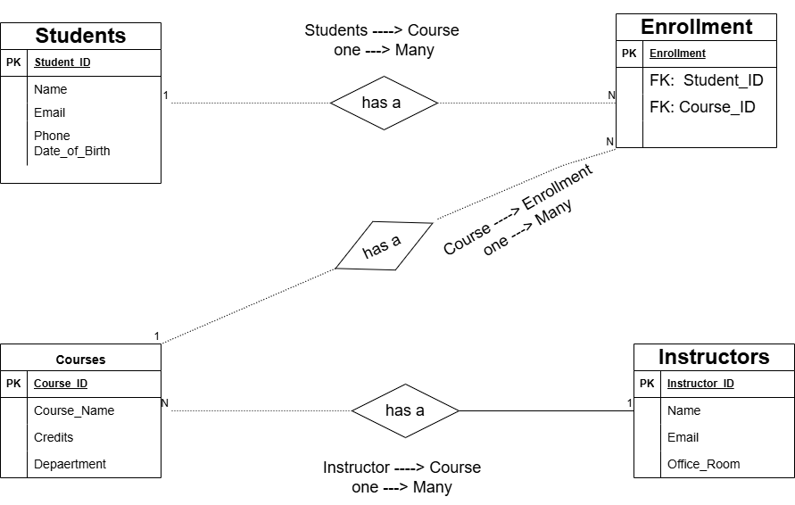

1. **Specify the primary keys (PK) and foreign keys (FK) for each table.**

1. Students:  
 Student_ID (PK)

2. Courses:

Course_ID (PK)

3. Instructors :

Instructor_ID (PK)

4. Enrollment :

Enrollemnt_ID (PK)

Student_ID (FK)

Course_ID (FK)

PK = Primary Key

FK = Foreign Key